**Unit 3 Triangle Congruence Exam**

*36 points*

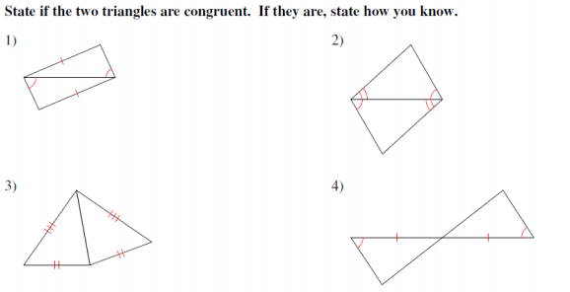*(2 points each)*

5) *(1 point)* 6) Find the value of x and y. *(2 points)*

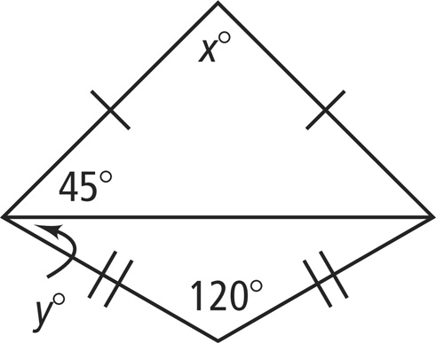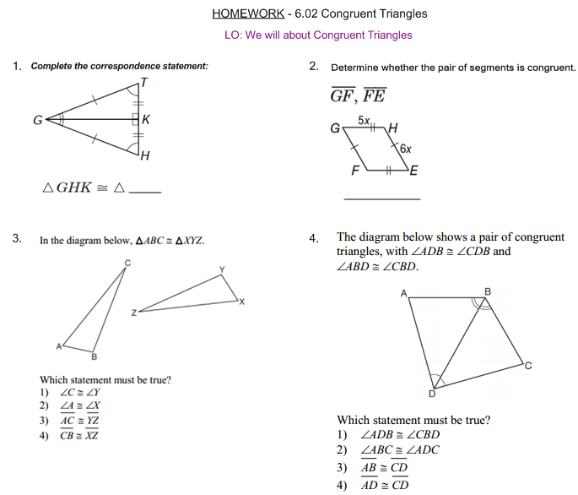

7) *(1 point)* 8) *(1 point)*

9) *(2 points)*

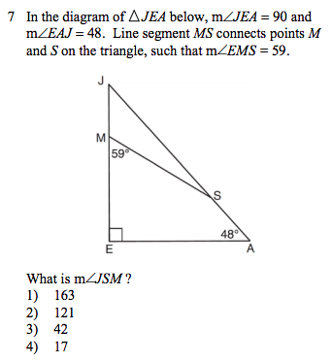

10) *(2 points)*

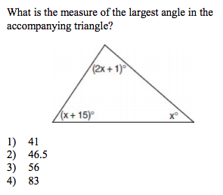

For questions 11 & 12, name a pair of overlapping congruent triangles in each diagram. State whether the triangles are congruent by SSS, SAS, ASA, AAS, or HL. *(2 points each)*

11) Given: ∠*E* ≅ ∠*C,* ≅

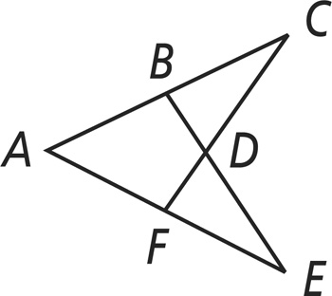

12) Given: ≅ *,*  ∠*FKJ* ≅ ∠*HJK*

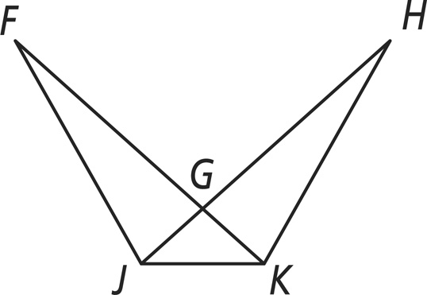

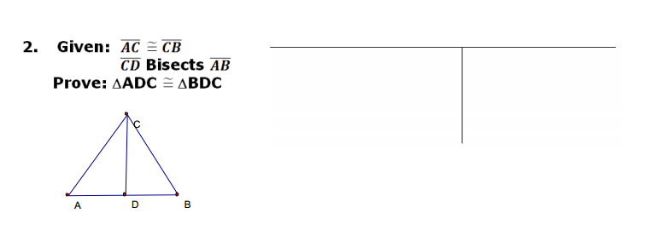13. Write a two column proof. *(5 points)*

**Given: $\overline{AC }$** ≅ $\overline{CB}$, $\overline{CD}$ bisects $\overline{AB}$

**Prove:** *∠CAD* ≅ *∠CBD*

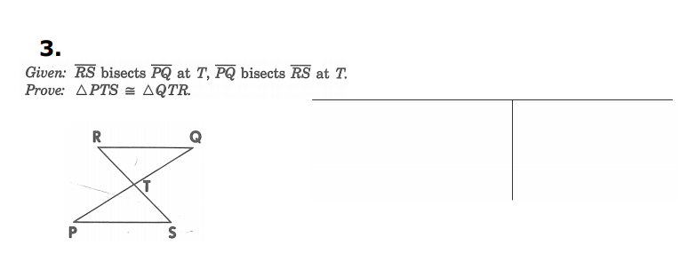14. Write a two column proof. *(6 points)*

**Given:** *T* is the midpoint of , ||

**Prove:** ∆*RTQ* ≅ ∆*STP*

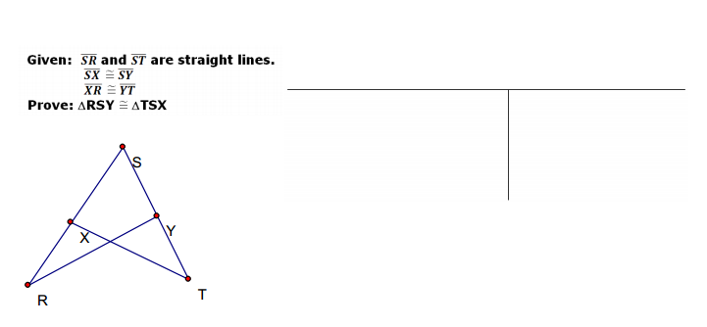15. Write a two column proof. *(4 points)*

**Given: $\overline{SR}$** ≅ $\overline{ST}$*, ∠SYR* ≅ *∠SXT*

**Prove:** ∆*RSY* ≅ ∆*TSX*

**Extra Credit** (+5 points)  
*Write a two column proof*